Apprenticeship in Tourism – Hotel
Tyrol, Austria
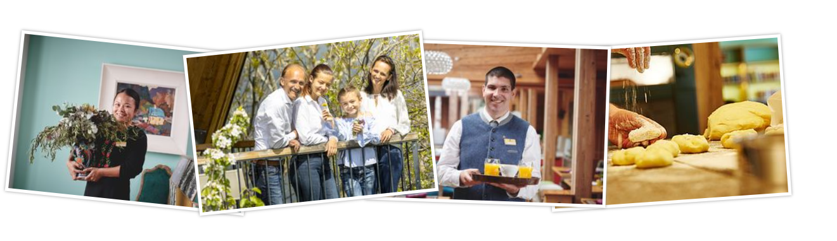
Employer | Registered Austrian company with service agreement for personnel search via EURES with the Public Employment Service / AMS Austria.  All applications will be preselected by the AMS EURES Advisor and in case of suitability forwarded to the employer.

Job title | Apprenticeship training in the hospitality industry in Zillertal/Tyrol/Austria
Skills:  Education, work experience, language, certificate, etc. | Language: Learn German from zero in the specially designed German class at the ZilleSeasons. German lessons three times a week with a professional teacher. After 6 months, admission to the A2 examination according to the "Common European Framework of Reference". Further language development is necessary. Goal after 2 years: B2 certification.  Previous knowledge of English will be highly valued to be able to communicate during the first months of stay.  Apprenticeships: Cook, Restaurant specialist, Hotel and hospitality assistant, Gastronomy specialist (4 years), Hotel clerk / Hotel management assistant, Confectioner / pastry chef, Beautician / Cosmetician (2 years)  Dual training system: Company and school. The company also offers an apprentice academy. Training in an apprenticeship profession of your choice in German language. Get to know top service quality in high-end hotel business. Attractive career opportunities.  What does a normal day look like: Our apprentices work at DasPosthotel and Hotel MalisGarten. Our service has 5* and 5*Superior level. Apprentices will be accommodated in one of our newly renovated staff houses. They will only be asked for a monthly contribution for electricity / water of EUR 40.00. Room facilities: fridge, TV, W-Lan, WC and shower; shared kitchen, fitness room (Waldheimat), sauna.  Clothes to bring: Ladies: Elegant, closed black shoes, white long-sleeved blouse. Men: Elegant, closed black shoes, black suit trousers reaching above the ankle, white long-sleeved shirts. In addition to these basics, we also provide high-quality staff clothing.
Working hours and place of work | The working hours are divided into early services (work starts at 6:30 a.m.), late shifts, medium shifts and partial shifts.  * The duty roster and days off depend on the hotel's workload.  * "FREE" requests will be considered if possible and can be submitted by  Thursday of the previous week.  * 6280 Zell am Ziller - Tyrol - Austria
Start date | As soon as possible
Salary | The remuneration is regulated by law and corresponds to the apprentice compensation according to the currently valid collective agreement in Tyrol  Framework rate per month from the 1st to the 4th year of apprenticeship:  € 815/€ 925/€ 1055/€ 1145 (2022) - all net! 14 times per year (In Austria there is a salary 13 and 14: holiday and Christmas bonus). Tip sharing is a matter of course!  Info on apprentice salary: https://www.wko.at/branchen/tourismus-freizeitwirtschaft/lehrlingsentschaedigung.html
Other information | The entire training costs for the German language and the apprenticeship are borne by the company. Accommodation in the newly renovated staff house. Flat rate for operating costs monthly € 40.00. Attendance catering.

Application
Last day for application | 31st December 2022
How to apply? | Curriculum vitae and motivation letter by e-mail in GERMAN or ENGLISH Language
Contact person/ telephone number | Ms. Helga Steinberger (EURES Advisor Tyrol)  0043 (0) 664 7876 8397  eures.tirol@ams.at  Please enter the code-word “Apprenticeship in Tyrol” in your application.

