
Would you like to be part of our shows and events at Disneyland Paris?

Characters & Parade Disneyland Paris Auditions Barcelona y Málaga
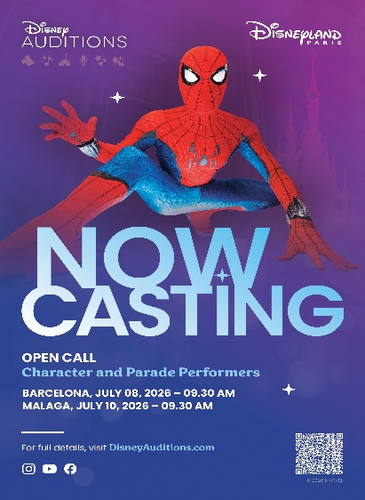

We are seeking:

> CHARACTER PERFORMER (F/M/NB) : spatially aware, energetic, creative with good physical stamina.
> CHARACTER & PARADE PERFORMERS (F/M/NB) : spatially aware, energetic, creative with good physical stamina. A good level of dance is required through significant training and/or stage experiences. Classical/ modern jazz style.
These positions require heights between 137cm and 193cm.

Contract type:

These positions are open for short-term and open-ended contracts.
Contract start dates available through a six-month period following the audition.
Short-term contract lengths are for a minimum of 3 months.
Housing possibilities are available.
Successful candidates requiring a Visa to work in France will be informed of the necessary application process.
These positions may include some night work and are subject to French law which requires candidates to be 18 years of age to legally work in France in accordance with the protection of young workers.

Audition Process

· STEP 1
Prior to arriving at the audition venue, please visit DisneyAuditions.com and click "My Profile" to create a performer profile. This only takes a few minutes and will save you time on the day of your audition.

· STEP 2
Click onto CheckIn@DisneyAuditions.com and select “Disneyland Paris - Character & Parade Audition – 10/07/2026 – MALAGA (SPAIN)” or Click onto CheckIn@DisneyAuditions.com and select “Disneyland Paris - Character & Parade Audition – 8/07/2026 – BARCELONA (SPAIN)”
Take your selfie to complete the check-in process.
There is no need to register more than once
Although we prefer that you check in online prior to the day of the audition, if you are unable to do so, you will have the opportunity to check in the morning of the audition (plan on an early arrival to do so before the start of the audition)
· STEP 3
Now that you have completed the audition check-in you simply need to join us on the day of the audition.
A Disneyland Paris representative will be present between 9.30am and 10am to welcome you.
You will not be asked to prepare any audition material prior to your arrival
Candidates may be asked to stay until 6 pm (At the very latest)
We would like to inform you that a team from Disneyland Paris will be present during the audition to capture some images which will be posted to the official Disneyland Paris social networks. Please inform us on your arrival if you do not wish to be filmed

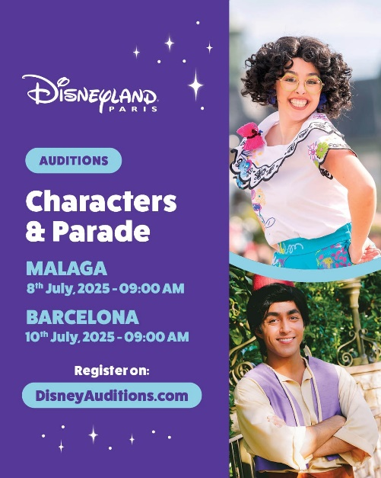
FRIDAY 10 JULY 2026
9.30 am
HEADWAY DANCE STUDIO
C. Lima, 7, Cruz de Humilladero
29006 Málaga, Espagne
WEDNESDAY 8 JULY 2026
9.30 am
SEVEN DANCE Carrer del Perill, 10, Gràcia, 08012 Barcelona, Espagne

Register on DisneyAuditions.com with a copy of the application eures.franciasuizabenelux@sepe.es

Ayudas a la movilidad EURES 

